**Google Cloud Vision API**

<https://cloud.google.com/vision/pricing>

<https://cloud.google.com/vision/docs/languages>

<https://cloud.google.com/vision/docs/pdf#vision_text_detection_pdf_gcs-python>

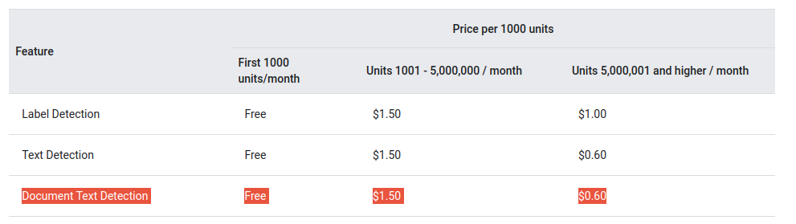

**Google Cloud Document AI**

<https://cloud.google.com/document-ai/pricing>

<https://cloud.google.com/document-ai/docs/processors-list>

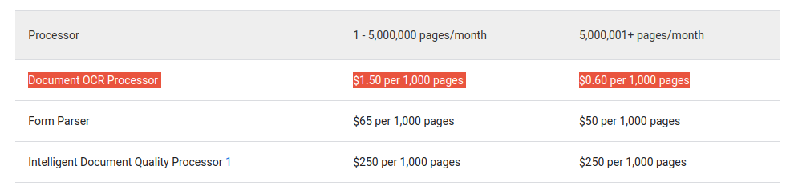

**Amazon Textract**

<https://aws.amazon.com/pt/textract/>

<https://aws.amazon.com/pt/textract/pricing/>

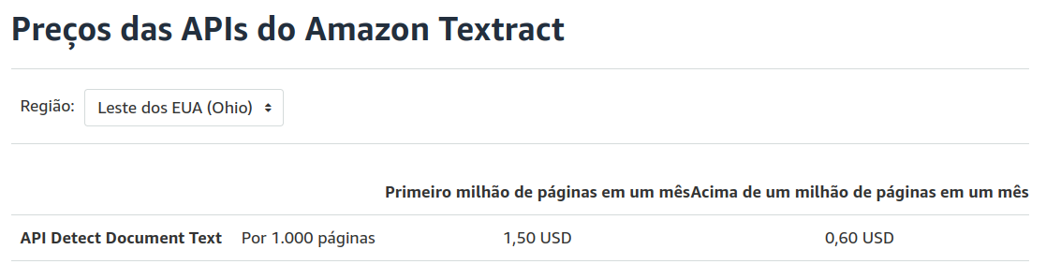

**Microsoft Azure - Form Recognizer Read (OCR)**

<https://learn.microsoft.com/en-us/azure/applied-ai-services/form-recognizer/concept-read?view=form-recog-3.0.0>

<https://azure.microsoft.com/en-us/pricing/details/form-recognizer/>

